
TECHNICAL PROPOSAL
FOR
DEVELOPMENT AND IMPLEMENTATION OF A
SCHOLARSHIP MANAGEMENT SYSTEM (SMS)

SUBMITTED TO
Press Trust Malawi
Internal Procurement and Disposal Committee

SUBMITTED BY



15 May 2026

CONFIDENTIAl
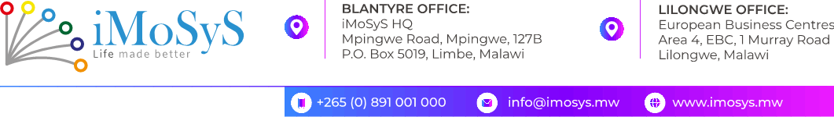

13 May 2026
The Chairperson
Internal Procurement and Disposal Committee
Press Trust
Floor 9, Kang'ombe House
P/Bag 359
Lilongwe 3
RE: PROPOSAL FOR DEVELOPMENT AND IMPLEMENTATION OF SCHOLARSHIP MANAGEMENT SYSTEM (SMS)
Dear Sir/Madam,
iMoSyS Limited is pleased to submit this Proposal for the Development and Implementation of a Scholarship Management System (SMS) for Press Trust Malawi, in accordance with the Terms of Reference issued April 2026 and the approved Software Requirements Specification (SRS) Version 1.2 dated 30 April 2026.
iMoSyS Limited is a Malawian ICT consultancy with over 15 years of experience designing, developing, and supporting enterprise information systems across the public and private sectors in Malawi and the region. We bring hands-on expertise in secure web-based workflow platforms, financial systems with maker–checker–approver controls, document management, reporting, and API-based integrations — capabilities directly relevant to the full scope of this assignment.
Our proposed solution is a secure, scalable, and configurable web-based Scholarship Management System covering Press Trust's full scholarship lifecycle — from beneficiary intake through to award management, disbursement, monitoring and evaluation, and reporting. The system will implement role-based access control, multi-factor authentication, TLS encryption, audit logging, and integration with SAGE Evolution, delivered by a team of seven specialists across 45 man-days over four calendar months, with 12 months of post-implementation support.
In submitting this proposal, iMoSyS Limited formally confirms the following:
- Proposal Validity: This proposal remains valid and binding for ninety (90) days from the submission date of 15 May 2026.
- Conflict of Interest: iMoSyS Limited has no conflict of interest — actual, perceived, or potential — in relation to this engagement, Press Trust, or any of its officers or stakeholders. Any conflict arising will be disclosed immediately.
- Acceptance of Terms of Reference: iMoSyS Limited has read, understood, and unconditionally accepts the Terms of Reference in their entirety, including all obligations, deliverables, reporting lines, and submission conditions.
- Accuracy of Submission: The information in this proposal is true and complete to the best of our knowledge, and iMoSyS Limited accepts full responsibility for its contents.
- SRS Compliance: iMoSyS Limited commits to delivering all mandatory functional and non-functional requirements in SRS Version 1.2. None of these requirements will be removed, substituted, or excluded.

We look forward to your favourable consideration of this submission. Please do not hesitate to contact us should you require any clarification.
Yours faithfully,


Gehazi Jenda
Chief Executive Officer
iMoSyS Limited
Company Registration No. COYR-RQ7TNQP

iMoSyS Limited | Registered in Malawi | Incorporated 30 November 2011

Table of Contents
1. Understanding of the Assignment 5
2. Proposed Methodology and Work Plan 5
Phase 1: Project Initiation & Requirements Validation 5
Phase 2: Business Process & Solution Design 5
Phase 3: System Development & Integration 6
Phase 4: Data Migration & Testing 6
Phase 5: Training, Deployment & Go-Live Support 6
Work Plan 6
3. Qualifications and Competence of the Team 6
4. Specific Experience Related to the Assignment 7
Capability Cross-Reference 8
A.1 Overview 10
A.2 Implementation Methodology 10
A.2.1 Governance Controls 11
A.3 Technology Approach 11
A.4 Low-Bandwidth and Usability Measures 11
A.5 Data Segregation and Access Isolation 11
A.6 Domain Module Implementation 12
A.6.1 Beneficiary Management 12
A.6.2 Institution Management 12
A.6.3 Application and Eligibility Management 12
A.6.4 Award and Disbursement Management 12
A.6.5 Document and Inventory Tracking 12
A.6.6 Monitoring, Evaluation and Compliance 12
A.6.7 Reporting and Audit 12
A.6.8 User, Access and Administration 13
A.7 DevOps, CI/CD and Release Management 13
A.8 Testing and Quality Assurance 13
B.1 Overview 15
B.2 Phase Detail 15
B.2.1 Phase 1: Project Initiation and Requirements Validation — Week 1 15
B.2.2 Phase 2: Business Process and Solution Design — Weeks 1–2 15
B.2.3 Phase 3: System Development and Integration — Weeks 2–7 15
B.2.4 Phase 4: Data Migration and Testing — Week 8 15
B.2.5 Phase 5: Training, Deployment and Go-Live — Week 9 15
B.2.6 Post-Implementation Support — Months 4–16 16
B.3 Summary Work Plan 16
B.3.1 Phase-Based Workplan — Gantt Chart 17
B.4 Non-Functional Performance Targets 18
C.1 Architectural Overview 20
C.2 End-to-End Request Flow 21
C.3 Scalability and Resilience 21
C.4 Infrastructure and Deployment 22
C.5 API and Integration Architecture 22
C.5.1 Integrations in Scope 23
C.5.2 Future Integrations 23
C.6 Observability, Monitoring and Alerting 24
C.7 Backup, Disaster Recovery and Business Continuity 24
C.8 Architecture Diagrams Summary 24
D.1 Migration Overview 26
D.2 Migration Scope 26
D.3 Migration Steps 26
D.4 Validation and Reconciliation 26
D.5 Cutover 26
D.6 Assumptions and Risks 27
E.1 Demonstration Approach 29
E.2 Demonstration Scenarios 29
F.1 Support Model 31
F.2 Support Channels 31
F.3 Incident Severity Classification and Response Targets 31
F.4 Maintenance Activities 31
F.5 Support Governance 31
F.6 Training and Knowledge Transfer Plan 31
F.6.1 Target Audiences 31
F.6.2 Training Approach 32
F.6.3 Knowledge Transfer 32
F.7 Documentation Package 32
G.1 Client References 34
H.1 Security Architecture 36
H.1.1 Identity and Authentication 36
H.1.2 Authorisation and Segregation of Duties 36
H.1.3 Application Security Controls 36
H.1.4 Network and Transport Security 36
H.1.5 Data Security 36
H.1.6 Audit and Monitoring 36
H.2 Security Certifications 36
H.3 Pre-Go-Live Security Assurance 37
I.1 Compliance with the Malawi Data Protection Act 39
I.2 Data Protection Policy Approach 39
I.3 Cybersecurity Assessment During Implementation 39
I.4 Post-Go-Live Cybersecurity Assessment 39
I.5 Expected Data Protection and Security Deliverables 40
J.1 Team Curriculum Vitae 42

TECHNICAL PROPOSAL
Development and Implementation of a Scholarship Management System (SMS)
Submitted to: Press Trust Malawi │ 15 May 2026

1. Understanding of the Assignment
Press Trust Malawi administers a secondary school scholarship programme targeting the best-performing boy and girl across Malawi's 34 educational districts. The current lifecycle relies on manual and spreadsheet-based processes, creating risks around transparency, financial governance, and beneficiary monitoring. The Trust requires a single digital platform to manage the full scholarship lifecycle — from Ministry of Education intake through to award management, disbursement, monitoring and evaluation, and reporting.
iMoSyS has reviewed the Terms of Reference (April 2026) and the Software Requirements Specification (SRS v1.2, 30 April 2026), covering 275+ functional requirements across 11 capability areas. The solution must address:
- End-to-end digitisation of the scholarship lifecycle, from Ministry of Education intake through to tertiary selection.
- Multi-level financial governance with configurable maker–checker–approver workflows, disbursement controls, and reconciliation.
- Role-based access control with field-level security and strict segregation of duties.
- Academic performance tracking, at-risk flagging, and intervention management for beneficiary monitoring.
- Configurable reporting with a dynamic report builder, exportable to PDF, Excel, and CSV.
- Integration with SAGE Evolution and the email gateway, with provision for future payment rail and SMS gateway connections.
- Migration of up to five years of historical Excel-based scholarship records.
- Delivery within 45 man-days across four calendar months, with 12 months of post-implementation support.

2. Proposed Methodology and Work Plan
The assignment will be delivered using a phased, Agile-based approach structured around five implementation phases, each producing client-approved deliverables before the next phase begins — keeping Press Trust actively involved at every decision point.

Phase 1: Project Initiation & Requirements Validation
Kick-off meeting to confirm scope, governance, and implementation priorities. The SRS will be validated against existing business processes and integration points to establish a shared baseline. Key outputs: validated requirements matrix; detailed implementation plan.

Phase 2: Business Process & Solution Design
Scholarship administration workflows are mapped and refined — approval processes, disbursement procedures, M&E reporting, and beneficiary management flows. BPFDs and DFDs are approved before configuration begins, alongside a solution architecture covering hosting, security, APIs, and DR. Key outputs: approved BPFDs, DFDs, and solution architecture.

Phase 3: System Development & Integration
The SMS is built on TypeScript/Next.js (frontend), Node.js (backend), and PostgreSQL (database), hosted on-premise or cloud per client preference. Eight core modules are delivered: Beneficiary Management, User & Access Management, Award Management, Financial & Disbursement Management, Document Management, Monitoring & Evaluation, Reporting & Analytics, and Institution Management. Security controls include SSL/TLS, AES encryption at rest, OAuth 2.0/JWT, MFA, and tamper-evident audit logging. Key outputs: configured and tested SMS modules; integration interfaces; API documentation.

Phase 4: Data Migration & Testing
Up to five years of historical Excel records are extracted, cleansed, validated, migrated, and reconciled. Testing covers unit, system integration, UAT, and OWASP-aligned security testing. Key outputs: migration report; UAT sign-off; test evidence package.

Phase 5: Training, Deployment & Go-Live Support
Role-based training delivered to administrators, operations, finance, M&E, and management staff — including practical sessions, user manuals, and administrator guides. After UAT sign-off, the system goes to production supported by a stabilisation period. Key outputs: trained users; deployed SMS; handover documentation; SLA commencement.

Work Plan
# | Phase | Key Activities & Deliverables | Timeline
1 | Project Initiation & Requirements Validation | Kick-off; scope and governance confirmation; SRS validation; stakeholder workshops; requirements matrix; implementation plan. | Week 1
2 | Business Process & Solution Design | Scholarship workflow mapping; BPFDs and DFDs; solution architecture (hosting, security, APIs, DR); Press Trust sign-off. | Weeks 1–2
3 | System Development & Integration | Full module development (8 core modules); SAGE Evolution and email gateway integration; REST API and security controls implementation. | Weeks 2–7
4 | Data Migration & Testing | Historical Excel data extraction, cleansing, migration, and reconciliation; unit, integration, UAT and OWASP security testing. | Week 8
5 | Training, Deployment & Go-Live | Role-based training; user and administrator guides; production deployment; post-go-live stabilisation. | Week 9
— | Post-Implementation Support | 12 months of structured technical support per SLA; incident management, bug fixes, and enhancement handling. | Months 4–16

3. Qualifications and Competence of the Team
The proposed team combines technical depth and direct experience with enterprise systems that closely mirror the SMS requirements — multi-role web platforms, financial controls, data migration, and workflow automation.
Name | Role | Relevant Qualifications & Experience
Esther Nyali | Project Manager | MSc Computer Science. Leads Old Mutual Malawi enterprise automation (RBAC, hierarchical approvals, audit trails). 8+ years IT project management.
Chimwemwe Chamangwana | Solution Architect / Tech Lead | Architected IntelSurv and PATIM (cloud-native, AWS, CI/CD, security-by-design). 8+ years system architecture and enterprise software.
Roosevelt Chingwalu | Backend Developer | Delivered MoH district-wide systems; cross-system integration. 5+ years REST API and workflow-based backend development.
Desire Mwanza | Business Analyst | Implemented Malawi Girls Can Code eLearning platform and national TB surveillance system. 5+ years business and systems analysis.
Kondwani Nantchito | Database Administrator | Built cross-border payment systems and NASTIS national logistics platform. 5+ years DBA experience (MySQL, PostgreSQL, SQL Server).
Stuart Winga | QA Lead | 13 years QA, infrastructure hardening, and user training across enterprise systems.
Chris Jossam & Immanuel Bester | Frontend Developers | Responsive low-bandwidth applications (Flutter, React, Next.js). 5+ years combined enterprise web frontend experience.

4. Specific Experience Related to the Assignment
The five projects below are directly comparable to the SMS in system complexity, governance requirements, and functional scope. Each is mapped to specific SMS capability areas.
# | Project | Client | Technology | What It Delivered | SMS Relevance
1 | Old Mutual Malawi — Enterprise Automation | Regulated financial services | Web + mobile; Spring Boot; PostgreSQL/AWS/S3 | Multi-level approval workflows; document catalogues; performance dashboards | Award/disbursement governance; maker–checker controls; audit patterns
2 | CDH Bank — Helpdesk & Request Management | Banking / internal controls | .NET Web API; SQL Server; email & identity | Request routing and approval workflows; SLA tracking; RBAC; full ticket history | User/access management; segregation of duties; operational dashboards
3 | MINET — Document Management System | Insurance / corporate | Web app; departmental repositories; hierarchical roles | Centralised records; folder permissions; version history; immutable audit logs | Document storage for applications and disbursement evidence; auditor access
4 | Riders for Health — NASTIS | National programme, MoH logistics | Laravel APIs; MySQL; SMS/email alerts | Multi-stage lifecycle tracking; TAT/SLA thresholds; automated escalations; national reporting | Beneficiary monitoring; intake-to-outcome pipeline; donor reporting
5 | E-Health — National TB Surveillance (MoH) | Public health, nationwide | Web dashboards; mobile capture; SMS gateway | Community-to-national data flow; validation layers; automated notifications | Applicant portal; bulk communications; M&E reporting; SAGE integration

Capability Cross-Reference
SMS Capability Area | Prior Project Experience
Beneficiary & institution management | E-Health (master data, facilities, roles); NASTIS (sites, hubs, actors); MINET (organisational units & access)
Application, eligibility & award management | CDH Bank (structured intake, routing, approvals); Old Mutual (onboarding data capture); E-Health (validation, status progression)
Financial & disbursement / maker–checker | Old Mutual (multi-level financial instruction approvals); CDH Bank (approval chains, SLAs)
Document management, versioning & audit | MINET (DMS); Old Mutual (versioned documents, S3); CDH Bank / NASTIS / E-Health (audit trails)
Reporting & analytics | All five projects (dashboards, exports, operational KPIs)
Notifications (email / SMS) | NASTIS and E-Health (automated alerts); CDH Bank and Old Mutual (email-driven workflow steps)
ERP and messaging integration | Old Mutual / CDH / E-Health (enterprise integration patterns) — transferable to SAGE Evolution and email gateway
National scale, reliability & DR | NASTIS and E-Health (production operations, backups, monitoring); Old Mutual (cloud resilience)

iMoSyS Limited | Submitted: 15 May 2026 | Confidential



Annex A
Approach and Methodology

Detailed description of the implementation methodology, technology approach, and domain modules

Press Trust Malawi │ Scholarship Management System (SMS)
Submitted by iMoSyS Limited │ 15 May 2026

CONFIDENTIAL

A.1 Overview
iMoSyS Limited will deliver the Scholarship Management System using a phased, Agile-based implementation approach structured around clear deliverables and client sign-off checkpoints at each phase. This approach ensures that Press Trust remains actively engaged throughout, and that requirements, design, security, testing, and deployment are governed appropriately throughout delivery.
The approach is grounded in four priorities: improving transparency and traceability across the scholarship lifecycle; strengthening financial stewardship through controlled approval workflows; supporting beneficiary performance monitoring and timely intervention; and equipping Press Trust with the documentation, training, and support needed to operate the platform confidently after go-live.

A.2 Implementation Methodology
The implementation follows five structured phases, each with defined activities, deliverables, and acceptance criteria. Phases run sequentially with appropriate parallel workstreams where schedule efficiency demands it.

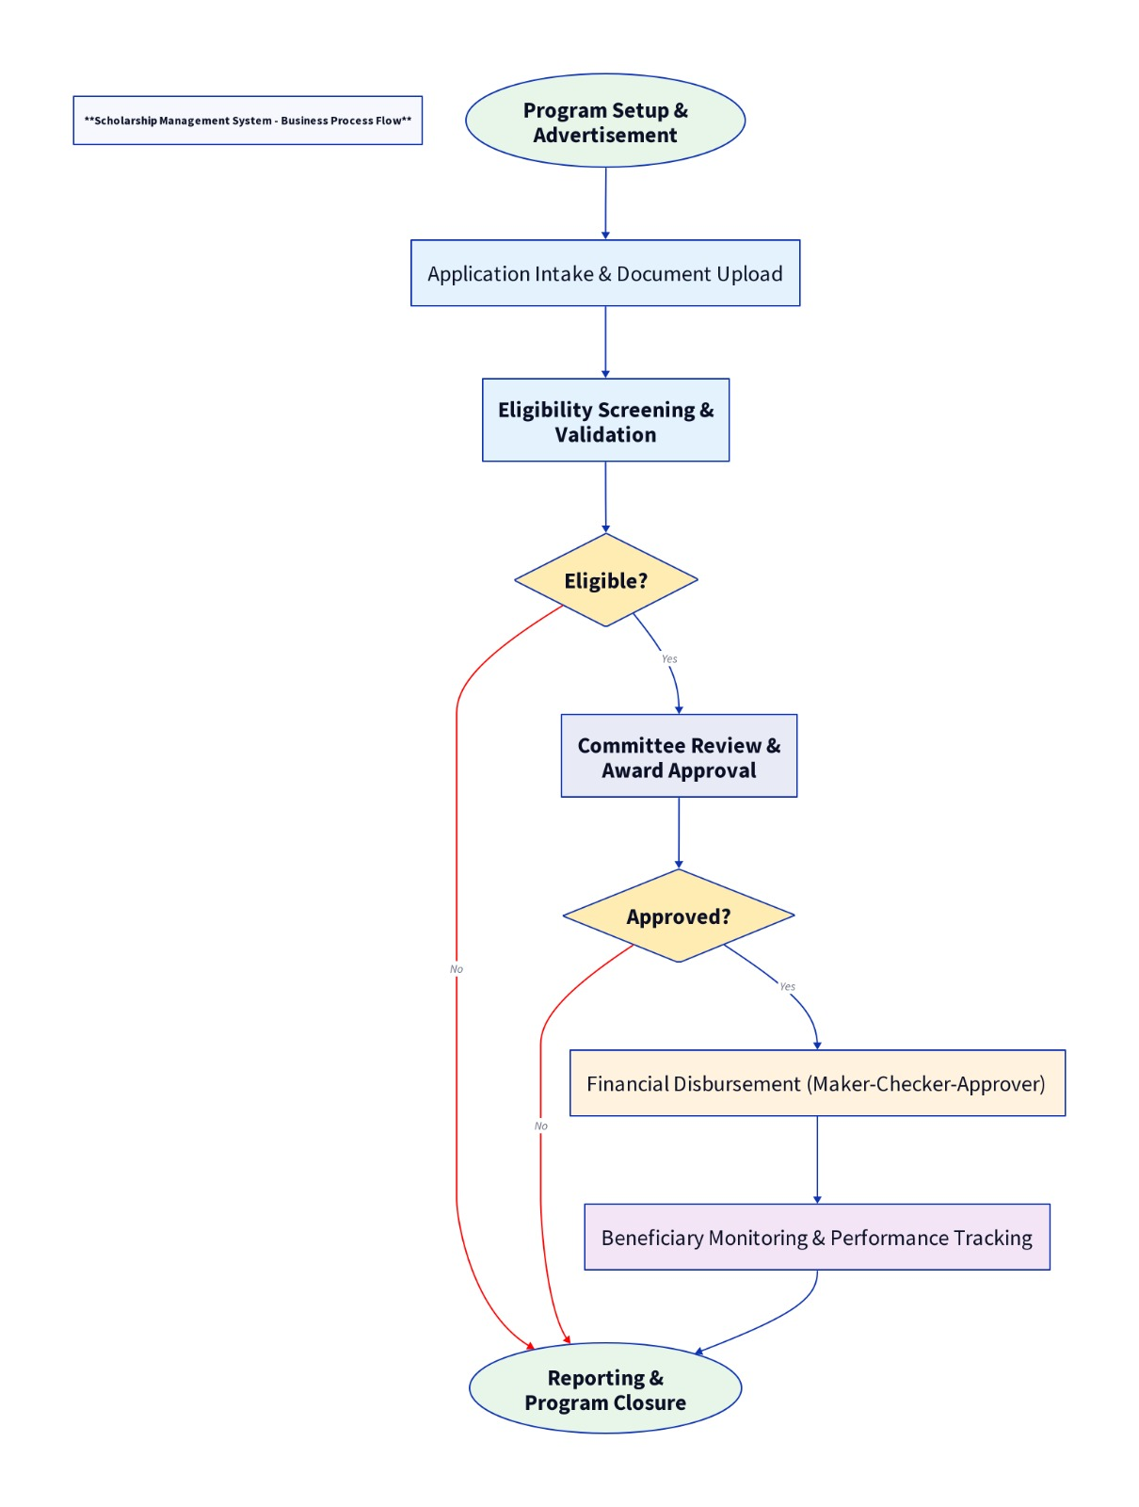
Figure 1. Business Process Flow Diagram — Press Trust Scholarship Lifecycle

A.2.1 Governance Controls
Project governance includes weekly progress review meetings, a risk and issue log, a decision register, a formal change control process, milestone acceptance checkpoints, and requirements traceability. Any change affecting scope, timeline, architecture, or delivery effort is assessed through formal governance before implementation proceeds.

A.3 Technology Approach
The implementation stack is selected to support secure web delivery, modular development, integration flexibility, low-bandwidth optimisation, and reliable long-term support.
Layer | Technology / Approach
Frontend | TypeScript with Next.js and React — responsive browser-based interface optimised for low-bandwidth access
Backend | Node.js with structured service architecture — RESTful APIs, workflow services, audit controls, and integration services
Database | PostgreSQL — secure, structured relational database for transactional records
Document Storage | Secure object/file storage for uploaded documents and generated report files
Authentication | OAuth 2.0 / JWT with MFA support; configurable session timeout and account lockout
Caching / Queuing | Redis or equivalent for notifications, background jobs, and report generation
API Layer | RESTful APIs secured by role-based access and request validation
Hosting | On-premise or approved cloud environment per Press Trust's hosting preference

A.4 Low-Bandwidth and Usability Measures
Since the SRS requires low-bandwidth optimisation, the frontend and service layer will implement efficient data loading with paginated list views, lazy loading of heavy interface sections, compressed assets and minimised payloads, controlled upload behaviour with resumable document handling, and background processing for report generation and large exports.

A.5 Data Segregation and Access Isolation
The SMS will enforce data isolation through role-based visibility by user class, program and sponsor-level scoping, beneficiary and institution-level ownership controls, restricted access to finance records and approval workflows, controlled document-level permissions, and export controls for privileged and read-only users.
Sensitive records contain personal, academic, and financial data. The SMS applies restricted visibility for sensitive fields: disbursement approval rights limited to authorised finance roles; restricted editing of scholarship decisions after approval; controlled access to audit logs and system configuration; and limited document download rights for sensitive beneficiary files.

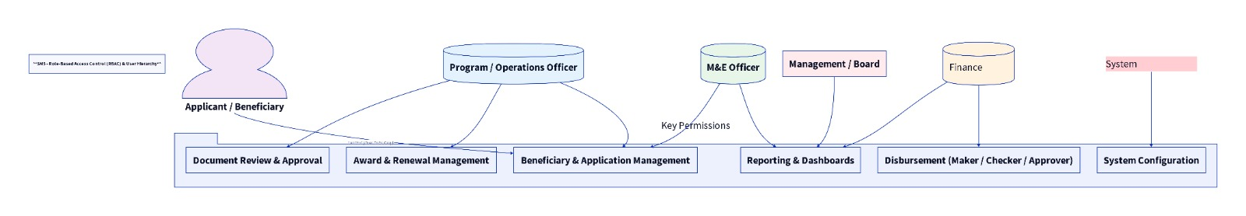
Figure 2. RBAC User Hierarchy Diagram

A.6 Domain Module Implementation

A.6.1 Beneficiary Management
Maintains applicant and beneficiary records across the full scholarship lifecycle — biodata, educational background, contact details, guardian details, and status tracking (applicant, shortlisted, approved, active, suspended, completed, terminated). Supports linkage to schools, districts, academic years, sponsors, and academic periods.

A.6.2 Institution Management
Maintains master data for schools and other institutions — institution type, district, location, contact details, and financial/payment details. Provides a single source of truth for institution records, reducing duplication in beneficiary assignment and reporting.

A.6.3 Application and Eligibility Management
Configurable application forms, intake windows, submission tracking, document upload, and eligibility checks using configured rules and controlled manual review. Maintains full application history including date submitted, validation status, reviewer comments, decision status, and approval path.

A.6.4 Award and Disbursement Management
Award management covers allocation decisions, award terms, duration, amounts, funding source linkage, conditions, award letters, renewals, and termination — with a full audit trail of decision history. Financial disbursement management handles schedules, amounts, payment references, maker-checker-approver workflows, payment evidence, and reconciliation. Supports linkage of disbursements to institutions, beneficiaries, sponsors, and funding sources.

A.6.5 Document and Inventory Tracking
Secure central storage for application documents, award letters, payment evidence, beneficiary acknowledgements, and monitoring records. Supports versioning, metadata tagging, search, restricted access, and document activity logging. In-kind support management covers purchased support items, quantity, valuation, issuance date, recipient acknowledgement, and evidence of receipt.

A.6.6 Monitoring, Evaluation and Compliance
Supports beneficiary academic progress tracking, milestone reporting, case notes, interventions, site visit records, performance exceptions, and compliance alerts — helping Press Trust identify at-risk beneficiaries and take timely action.

A.6.7 Reporting and Audit
Operational reports, management dashboards, ad hoc reporting, and standard exports to PDF, Excel, and CSV covering beneficiaries, schools, districts, sponsors, academic periods, awards, disbursements, budget utilisation, compliance, and monitoring. Audit logging captures user activity, approval actions, record changes, communication activity, and administrative changes.

A.6.8 User, Access and Administration
User registration, role assignment, password policy enforcement, configurable permissions, workflow setup, notification templates, and reference data management — all governed through RBAC aligned to Press Trust's approved operating model.

A.7 DevOps, CI/CD and Release Management
The delivery pipeline includes source code commit and branch validation, automated build and test execution, static code and dependency scanning, package and artifact versioning, controlled deployment to test or staging environments, and formal promotion to production upon approval. Every release is accompanied by release notes, a deployment checklist, rollback steps, post-deployment verification results, and change approval evidence.

A.8 Testing and Quality Assurance
Testing is performed as an evidence-based, phase-gated activity covering unit testing, integration testing, end-to-end system testing, User Acceptance Testing, performance and load testing, OWASP-aligned security testing, and regression testing. Test cases are mapped to approved requirements. Defects are classified by severity and business impact, with closure requiring validation and regression confirmation.
UAT will be conducted using realistic scholarship scenarios drawn from Press Trust's operating model, covering routine and exception cases across beneficiary management, award processing, finance, documents, monitoring, and reporting.



Annex B
Implementation Plan, Work Plan and Timeline

Phase-by-phase plan across the 45 man-day, four-month engagement

Press Trust Malawi │ Scholarship Management System (SMS)
Submitted by iMoSyS Limited │ 15 May 2026

CONFIDENTIAL

B.1 Overview
The proposed work plan is structured over four calendar months, with approximately 45 man-days distributed across analysis, design, build, testing, deployment, handover, and governance activities. The plan comprises five implementation phases, each with defined activities, deliverables, and acceptance criteria, followed by 12 months of post-implementation support.

B.2 Phase Detail

B.2.1 Phase 1: Project Initiation and Requirements Validation — Week 1
Activities: kick-off meeting; scope and governance confirmation; SRS review and validation; stakeholder workshops; confirmation of integrations, hosting assumptions, and reporting priorities; preparation of validated requirements matrix and implementation plan.
Deliverables: project initiation report; validated requirements matrix; detailed implementation and governance plan.
Acceptance: requirements and scope validated, assumptions documented, and implementation governance approved by Press Trust.

B.2.2 Phase 2: Business Process and Solution Design — Weeks 1–2
Activities: scholarship workflow mapping; approval workflow definition; disbursement and reconciliation process design; M&E and reporting process design; architecture and security design; data migration planning; integration design.
Deliverables: approved workflow diagrams; data flow diagrams; solution architecture package; security and integration design notes.
Acceptance: workflow designs, architecture diagrams, security principles, integration design, and migration approach reviewed and accepted by Press Trust.

B.2.3 Phase 3: System Development and Integration — Weeks 2–7
Activities: development and configuration of all core modules; workflow implementation; reporting setup; API and integration build; audit and notification features; internal sprint reviews and demonstrations.
Deliverables: configured SMS modules; API baseline; integration interfaces; demonstration evidence.
Acceptance: core modules, APIs, workflows, audit controls, and key reports demonstrably operational in the test environment.

B.2.4 Phase 4: Data Migration and Testing — Week 8
Activities: historical Excel data extraction and mapping; cleansing and transformation; migration dry runs; unit, integration, system, UAT, and security testing; reconciliation and defect correction.
Deliverables: data migration report; reconciliation report; test evidence pack; UAT support outputs.
Acceptance: testing completed with acceptable pass rates; critical defects resolved; migration dry-run results reviewed and accepted by Press Trust.

B.2.5 Phase 5: Training, Deployment and Go-Live — Week 9
Activities: role-based training; documentation handover; production deployment; hypercare and stabilisation; formal handover and support commencement.
Deliverables: training completion report; production deployment report; handover documentation; go-live acceptance record.
Acceptance: training completed; production deployment successful; key workflows operating correctly in production.

B.2.6 Post-Implementation Support — Months 4–16
Activities: incident and support management; patch and bug-fix support; performance review; service review reporting; preventive maintenance actions. Severity 1 and Severity 2 defects that materially affect operations, security, finance controls, or compliance must be resolved before production acceptance unless formally waived.

B.3 Summary Work Plan
# | Phase | Key Activities & Deliverables | Timeline
1 | Project Initiation & Requirements Validation | Kick-off; scope and governance confirmation; SRS validation; stakeholder workshops; requirements matrix; implementation plan. | Week 1
2 | Business Process & Solution Design | Workflow mapping; approval and disbursement process design; BPFDs and DFDs; solution architecture; security and integration design. | Weeks 1–2
3 | System Development & Integration | Core module development; workflow implementation; reporting; API and integration build; audit and notification features. | Weeks 2–7
4 | Data Migration & Testing | Historical data extraction, cleansing, migration, dry runs; unit, integration, UAT, and security testing; reconciliation. | Week 8
5 | Training, Deployment & Go-Live | Role-based training; documentation handover; production deployment; hypercare; formal handover. | Week 9
— | Post-Implementation Support | 12 months structured support per SLA: incident management, bug fixes, patching, performance review, service reviews. | Months 4–16

B.3.1 Phase-Based Workplan — Gantt Chart
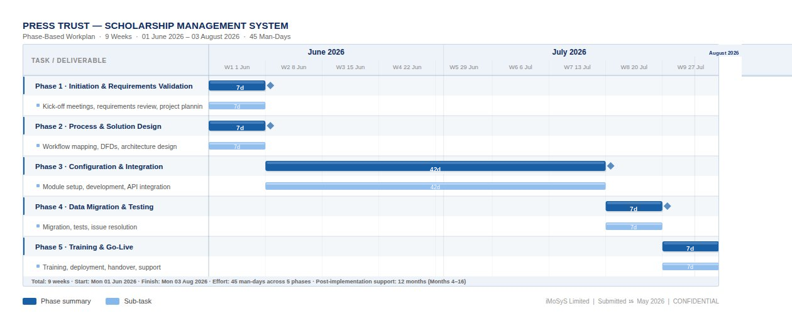
Figure B.1: Press Trust Scholarship Management System — Phase-Based Workplan (9 weeks, June–August 2026)

B.4 Non-Functional Performance Targets
Indicative non-functional targets to be confirmed during design:
- Core system availability: 99.5% to 99.9% depending on final hosting model.
- p95 response time: below 2 seconds for standard transactional requests under expected load.
- Controlled degradation for heavy reporting or export workloads.
- Resume-friendly behaviour for document uploads in low-bandwidth environments.
- Threshold-based alerts for failed background jobs and integration errors.



Annex C
System Architecture

Proposed target architecture, infrastructure deployment, API integration, and all architecture diagrams

Press Trust Malawi │ Scholarship Management System (SMS)
Submitted by iMoSyS Limited │ 15 May 2026

CONFIDENTIAL

C.1 Architectural Overview
The proposed SMS will be implemented using a layered, modular, API-first architecture providing clear separation of concerns, predictable scalability, easier supportability, and strong control over security, auditing, integration, and reporting. The architecture comprises eight layers: Presentation, Access and Edge, Application Services, Workflow and Rules, Integration, Data, Cross-Cutting Security, and Observability.

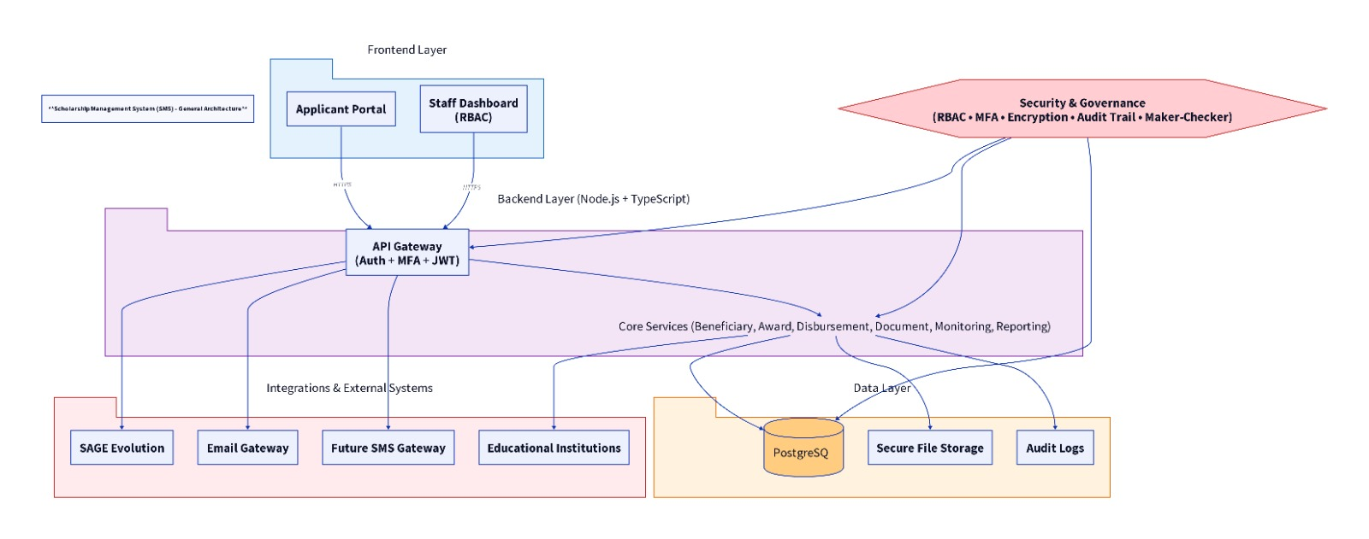
Figure 3. High Level Architecture Diagram — iMoSyS SMS for Press Trust

The eight layers in detail:
- Presentation Layer: browser-based interfaces for applicants, internal users, administrators, and read-only stakeholders.
- Access and Edge Layer: secure ingress, TLS termination, request routing, session handling, and request-level security checks.
- Application Services Layer: core scholarship business logic for all functional modules.
- Workflow and Rules Layer: approval routing, configurable stage transitions, notification triggers, escalations, and business-rule enforcement.
- Integration Layer: controlled APIs and adapters for SAGE Evolution, email gateway, and future integrations.
- Data Layer: relational database, document storage, reporting datasets, audit records, and controlled import/export mechanisms.
- Cross-Cutting Security Layer: authentication, authorisation, audit logging, privileged access control, and policy enforcement.
- Observability Layer: centralised logging, metrics, alerting, operational dashboards, and health monitoring.

C.2 End-to-End Request Flow
A typical transaction within the SMS follows this pattern: the user authenticates and receives an approved session or token; the request reaches the secured application edge where transport security, request validity, and access policies are checked; the relevant business service validates the request and applies module-level business rules; if the action requires workflow progression, the workflow engine processes state changes, approvals, or escalations; valid changes are committed to the database and linked audit events are recorded; notifications, report updates, or integration events are triggered where required; and a standardised response is returned to the user interface.

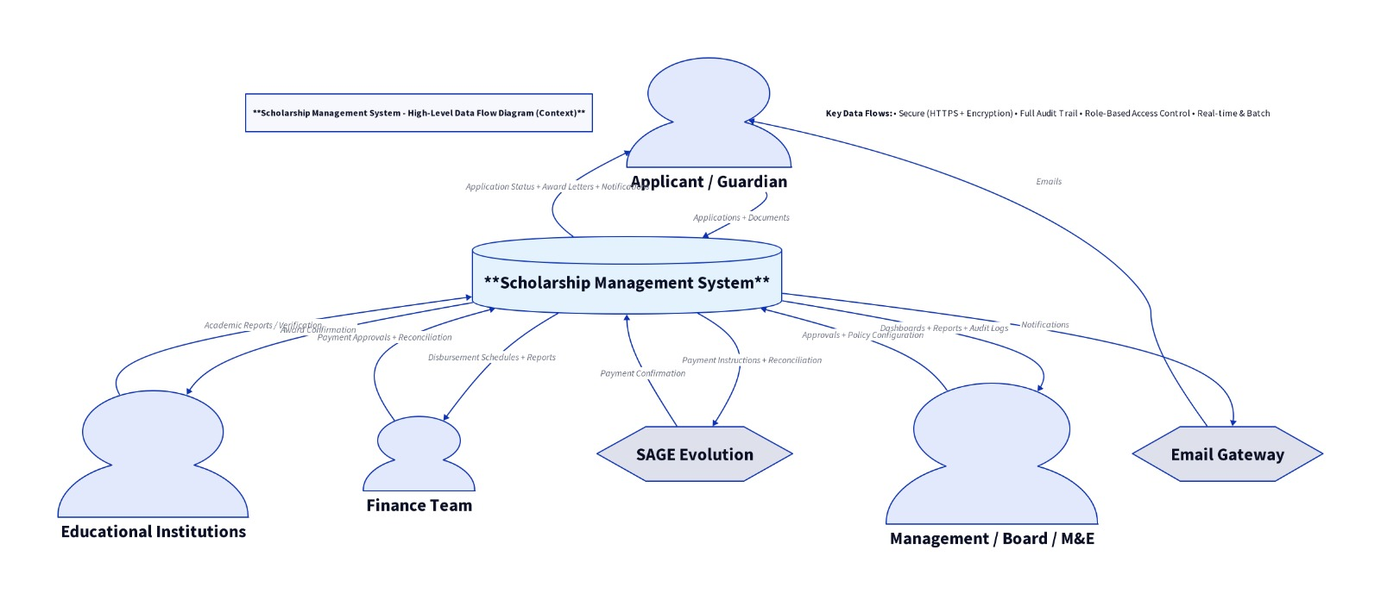
Figure 4. High Level Data Flow Diagram — SMS Core Entities and Flows

C.3 Scalability and Resilience
The architecture supports scaling at the application and data access layers. Stateless application services can be scaled horizontally where needed. Structured indexing, caching, and background processing improve performance for high-volume workflows such as reporting, document retrieval, and notifications. Resilience controls include retry logic for non-critical external calls, error isolation, health checks, and monitoring-based alerting. Critical processes such as disbursement approvals and data migration include stronger validation, reconciliation, and rollback controls.

C.4 Infrastructure and Deployment
The proposed SMS is deployable within Press Trust's approved on-premise environment or in an approved cloud or hosted environment. The final deployment model will be agreed during design, taking into account policy, budget, supportability, and disaster recovery considerations. The implementation will provide separate environments for development, testing/UAT, and production.
Infrastructure scope includes: compute and runtime provisioning; database installation and hardening; secure document storage setup; network segmentation and ingress controls; domain and certificate configuration; environment-specific configuration and secret handling; and monitoring and backup setup.

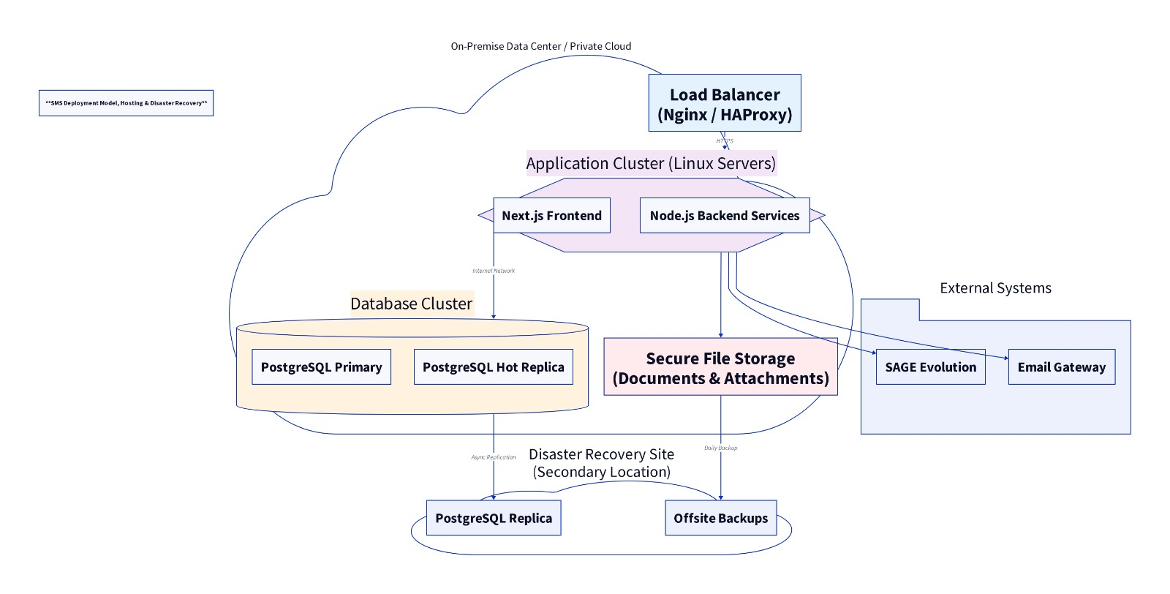
Figure 5. Deployment Model, Hosting and Disaster Recovery Architecture

C.5 API and Integration Architecture
All core integration endpoints follow structured REST principles with clear payload formats, validation rules, error handling, and versioning. Integration services support secure authentication, auditable transactions, and correlation of requests for troubleshooting and reconciliation.

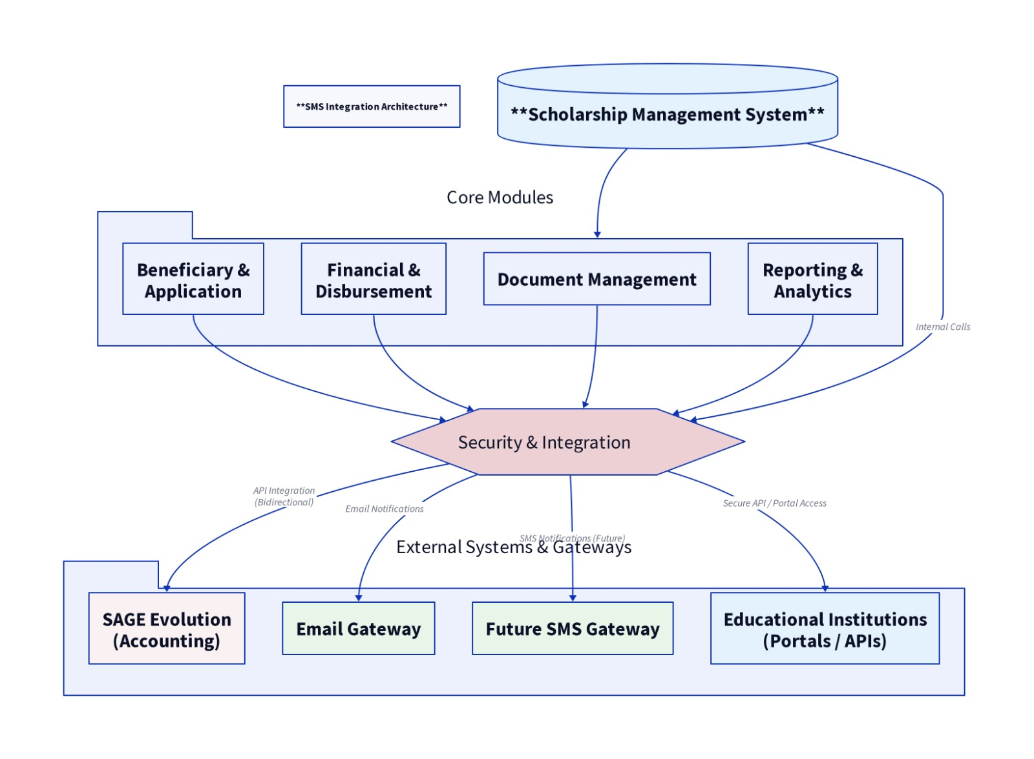
Figure 6. Scholarship System Integration Architecture Diagram

C.5.1 Integrations in Scope
- SAGE Evolution: approved financial posting or export processes governed through interface controls.
- Email gateway: transactional and bulk communications via configurable SMTP with encrypted credentials.

C.5.2 Future Integrations
- SMS gateway for beneficiary and school communications.
- Payment rails for electronic disbursements and payment status callbacks.
- Third-party identity systems for optional SSO where required.
Each integration is governed by a technical contract covering authentication method, endpoint definition, payload structure, validation rules, retry and timeout policy, error handling, reconciliation method, and operational ownership.

C.6 Observability, Monitoring and Alerting
Monitoring covers application health and availability, API response times and error trends, background job and notification status, database resource health, integration success and failure trends, security-relevant events, and backup job status. High-impact issues — system outages, disbursement workflow failures, failed integrations, and backup failures — trigger immediate operational alerts.

C.7 Backup, Disaster Recovery and Business Continuity
Backup implementation includes scheduled full and incremental backups, encrypted backup storage, backup retention rules, backup integrity verification, and recovery documentation. Indicative recovery objectives (subject to final agreement based on hosting model and risk appetite):
- Recovery Point Objective (RPO): up to 24 hours.
- Recovery Time Objective (RTO): up to 48 hours.
Where partial downtime affects core operations, documented fallback procedures will preserve continuity while restoration is underway.

C.8 Architecture Diagrams Summary
The following diagrams are included in this annex. Additional diagrams — including a solution context diagram, logical application architecture, role-based access and security boundary diagram, scholarship lifecycle workflow diagram, and maker-checker-approver disbursement workflow diagram — will be produced and approved during the design phase.
Figure | Diagram | Location in Proposal
Figure 3 | High Level Architecture Diagram | Annex C, Section C.1
Figure 1 | Business Process Flow Diagram | Annex A, Section A.2
Figure 4 | High Level Data Flow Diagram | Annex C, Section C.2
Figure 2 | RBAC User Hierarchy Diagram | Annex A, Section A.5
Figure 6 | Scholarship System Integration Architecture Diagram | Annex C, Section C.5
Figure 5 | Deployment Model, Hosting and Data Recovery Diagram | Annex C, Section C.7



Annex D
Data Migration Approach

Extract, map, cleanse, load, validate, reconcile, and cutover methodology

Press Trust Malawi │ Scholarship Management System (SMS)
Submitted by iMoSyS Limited │ 15 May 2026

CONFIDENTIAL

D.1 Migration Overview
The proposed migration approach follows a controlled extract, map, cleanse, load, validate, reconcile methodology. The SMS will support migration of up to five years of historical records from Excel-based sources where source quality is acceptable. Source data quality will be assessed during the design phase, and material gaps will be escalated and agreed with Press Trust before migration begins.

D.2 Migration Scope
Historical scholarship data — up to five years of Excel-based records — will be extracted, cleansed, validated against SRS data quality rules, migrated into the new system, and reconciled. Migration will cover: beneficiary records; school and institution records; award records; disbursement records; academic performance records; sponsor and funding source records; and supporting documentation where available.

D.3 Migration Steps
Step | Activity | Description
1 | Source Inventory & Profiling | Identify and document all source Excel files; assess record counts, field completeness, data quality issues, and gaps.
2 | Field Mapping | Map source columns to target SMS data structures; document transformation rules, default values, and exception handling.
3 | Cleansing & Normalisation | Standardise formats (dates, phone numbers, identifiers); resolve duplicates; handle missing mandatory fields; apply business rules.
4 | Staging Load | Load cleansed data into staging structures for validation before final system import.
5 | Validation & Reconciliation | Validate record counts, mandatory field completeness, referential integrity, financial totals, and institution/sponsor alignment.
6 | Business Review & Sign-off | Present validation reports to Press Trust; agree on exception handling for records that cannot be migrated.
7 | Final Cutover Load | Execute final migration load in coordination with the go-live freeze window.

D.4 Validation and Reconciliation
- Record counts matched between source and target.
- Mandatory field completeness checks across all migrated entities.
- Referential integrity checks — beneficiaries linked to valid schools, programs, and sponsors.
- Financial total comparisons — award amounts and disbursement totals reconciled against source records.
- Random sample verification of migrated beneficiaries and awards.
- Institution and sponsor alignment checks.

D.5 Cutover
Cutover planning includes: a freeze window to prevent changes to source data during the final load; a sequenced final load plan covering all entity types in dependency order; documented rollback criteria and rollback procedure; and post-cutover confirmation checks before go-live declaration. A data migration report and reconciliation report will be submitted as part of Phase 4 deliverables.

D.6 Assumptions and Risks
- Press Trust will provide timely access to all source Excel files and relevant stakeholders for data review workshops.
- Source data quality will be assessed during profiling; any material gaps will be escalated before migration begins.
- Records that cannot be cleansed to acceptable standards will be documented and excluded with Press Trust's agreement.
- The migration will be rehearsed through dry runs before the final cutover load.



Annex E
Demonstration Plan

Mapping the proposed solution to mandatory SRS requirements through scripted demonstration scenarios

Press Trust Malawi │ Scholarship Management System (SMS)
Submitted by iMoSyS Limited │ 15 May 2026

CONFIDENTIAL

E.1 Demonstration Approach
iMoSyS will demonstrate the solution through scripted scenarios during UAT and, where helpful, through a pre-UAT walkthrough. Each scenario defines preconditions, user steps, expected results, and objective evidence. The demonstration plan maps directly to the mandatory requirements in the SRS and the TOR evaluation criteria.

E.2 Demonstration Scenarios
Scenario | Description | Evidence
Web-based & low-bandwidth performance | Loading of key pages under constrained network conditions; pagination of large lists; resumable document upload. | Performance notes, timings, upload behaviour logs.
Beneficiary & institution management | Create and edit an institution record; register a beneficiary; link to a school and academic period; demonstrate duplicate prevention. | Screenshots, audit history, uniqueness validation messages.
Application & eligibility management | Configure an application form; submit an application; apply automated eligibility rules; perform a manual override with justification. | Workflow history, decision logs, override audit trail.
Award & disbursement management | Create an award; define payment schedule; complete maker-checker-approver workflow; capture payment evidence before marking Paid. | Approval trail, role separation evidence, payment record with evidence.
Inventory & in-kind support | Record support item procurement; issue items to a beneficiary; capture valuation and beneficiary acknowledgement. | Issuance record, inventory log, signed acknowledgement document.
Sponsor & funding source linkage | Link awards and beneficiaries to sponsors or funding sources; generate filtered sponsor-specific reporting. | Excel/PDF export with sponsor-filtered data.
Monitoring & compliance | Capture academic progress; trigger alert for poor performance or non-compliance; process continuation or suspension decision. | Alert log, beneficiary case record, status audit trail.
Reporting & audit | Generate standard and ad hoc reports; use dashboard filters; export outputs to CSV, Excel, and PDF. | Report outputs, export logs, audit logs.
Document management | Upload documents; review version history; test denied access for unauthorised roles; retrieve files through search. | Document history, access control results, audit log of download attempts.
Notifications & communication logging | Send template-based notifications and bulk communication; review communication logs. | Notification activity records, log showing recipient, timestamp, and status.
Administration & no-code configuration | Adjust a workflow stage, notification template, or reference configuration without code deployment. | Change log, configuration audit, confirmation that change is effective without redeployment.
Integrations | Demonstrate SAGE Evolution handoff or export; reconcile transaction totals; send email through approved gateway. | Integration logs, reconciliation report, sent email confirmation.
Security & access control | Demonstrate RBAC restrictions; password policy enforcement; auditor read-only access; MFA login flow. | Security test records, screenshots of blocked access for unauthorised roles.



Annex F
Support and Maintenance Model

Post-implementation support model, SLA commitments, training, and knowledge transfer plan

Press Trust Malawi │ Scholarship Management System (SMS)
Submitted by iMoSyS Limited │ 15 May 2026

CONFIDENTIAL

F.1 Support Model
iMoSyS will provide structured post-go-live support to ensure service stability, controlled issue resolution, and continuity of operations across the 12-month post-implementation period. Support will be provided through a business-hours helpdesk with escalation to Level 2 engineering and Level 3 product engineering as required.

F.2 Support Channels
- Ticketing portal — primary channel for all support requests.
- Email — for non-urgent issues and service queries.
- WhatsApp — for quick communication and status updates.
- Phone — for Severity 1 incidents requiring immediate escalation.

F.3 Incident Severity Classification and Response Targets
Severity | Definition / Examples | Initial Response | Resolution Target
Severity 1 | Production unavailable, critical control failure, or confirmed data exposure. E.g. system down; disbursement workflow blocked. | Within 1 business hour | Best efforts same business day
Severity 2 | Major business function impaired. E.g. award or disbursement module inaccessible; reports failing. | Within 4 business hours | Within 3 business days
Severity 3 | Minor defect with workaround available. E.g. non-critical export error with manual workaround. | Within 1 business day | Within 10 business days
Severity 4 | Cosmetic issue or enhancement request. E.g. UI label change; minor formatting improvement. | Within 3 business days | By agreement

F.4 Maintenance Activities
- Bug fixes and issue resolution — defect correction with regression testing.
- Patch deployment — application and dependency security patches, with acceleration for critical vulnerabilities.
- Performance tuning guidance — recommendations based on observed usage and load patterns.
- Minor configuration support — adjustments to workflows, notification templates, and reference data.
- Monthly support reporting — summary of incidents, resolution times, and recurring issues.

F.5 Support Governance
Post-go-live support governance includes monthly service review meetings between iMoSyS and Press Trust, incident trend analysis and continuous improvement recommendations, and annual DR drill participation where required by Press Trust's operational policies.

F.6 Training and Knowledge Transfer Plan

F.6.1 Target Audiences
Training will be tailored for: system administrators; operations and program staff; finance users; M&E users; management and reporting users; and auditors or read-only reviewers where required.

F.6.2 Training Approach
Training combines guided walkthroughs, scenario-based exercises aligned to real Press Trust scholarship processes, practical demonstrations, user manuals and quick reference guides, and Q&A sessions. All training will be conducted before the go-live deployment.

F.6.3 Knowledge Transfer
Technical knowledge transfer covers user administration, workflow configuration, report usage, routine support actions, monitoring, backup checks, and escalation handling — enabling Press Trust's administrators to manage day-to-day system operations with confidence after handover.

F.7 Documentation Package
The documentation set delivered at handover includes: solution architecture document; installation and deployment guide; system administration guide; user manuals by role; API and integration guide; security operations guide; backup and recovery procedure; incident and escalation procedure; configuration and workflow guide; and release and maintenance guide. All documents will be versioned and aligned to the final deployed solution.



Annex G
Client References

Recent client references confirming comparable system delivery experience

Press Trust Malawi │ Scholarship Management System (SMS)
Submitted by iMoSyS Limited │ 15 May 2026

CONFIDENTIAL

G.1 Client References
Three client references from recent engagements of comparable scope and complexity are provided below. References confirm iMoSyS Limited's demonstrated capability to design, develop, deploy, and support enterprise information systems with governance, financial controls, reporting, and integration requirements similar to those of the Press Trust Scholarship Management System.

Old Mutual Malawi Limited | Project: Enterprise Automation System (EAS) | Sector: Financial Services | Description: Design, development, and deployment of a web-based enterprise workflow automation platform with role-based access control, hierarchical approval chains, document management, audit trails, and management dashboards. Comparable to the SMS in governance controls, maker-checker workflows, and data management scope. | Delivery Period: August 2024 – Present (Ongoing) | Contract Value: MK 351,000,032 | Contact Person: Gerald Chungu | Position: Head of ICT | Telephone: +265 891 002 010 | Email: gchungu@oldmutual.co.mw
Ministry of Health, Malawi | Project: NASTIS — National Asset Tracking and Information System (implemented through Riders for Health) | Sector: Public Health / National Programme | Description: Design and deployment of a national logistics and asset tracking platform covering all health districts in Malawi, with multi-stage lifecycle tracking, SLA thresholds, automated escalation, SMS and email notifications, and national dashboards. Comparable to the SMS in national scale, multi-role workflows, beneficiary monitoring, and integration requirements. | Delivery Period: January 2026 – September 2026 (Ongoing) | Contract Value: MK 43,775,000| Contact Person: Lucy Chiyenda | Position: Country Director Email: lchiyenda@r4hmw.org
Ministry of Health, Malawi | Project: National TB Surveillance System (E-Health Programme) | Sector: Public Health / National Programme | Description: Design, development, and deployment of a nationwide disease surveillance system with web dashboards, mobile data capture, a centralised data repository, SMS gateway integration, lab-linked workflows, and automated notifications from community level to national reporting. Comparable to the SMS in multi-level data flows, validation layers, M&E-style reporting, and bulk communication requirements. | Delivery Period: 2017 – 2023 | Contract Value: MK 505,000,000.00 | Contact Person: Dr Kuzani Mbendera | Position: National TB Coordinator | Email: kuzaninigelmbendera@gmail.com



Annex H
Security Certifications and Assurance

Security architecture, assurance approach, and evidence of security maturity

Press Trust Malawi │ Scholarship Management System (SMS)
Submitted by iMoSyS Limited │ 15 May 2026

CONFIDENTIAL

H.1 Security Architecture
Security is implemented as a core design principle across all layers of the SMS, protecting applicant, beneficiary, institutional, financial, and operational data through layered technical and procedural controls.

H.1.1 Identity and Authentication
Secure user authentication with password policy enforcement, configurable session timeout, account lockout after a configurable number of failed attempts, and multi-factor authentication for all users. Administrative access is further restricted and monitored.

H.1.2 Authorisation and Segregation of Duties
Role-based access control with least-privilege principles. Sensitive actions — disbursement approval, configuration changes, role assignment, and administrative overrides — require appropriate privilege and are fully logged. Segregation of duties is enforced between disbursement creation (Maker), checking (Checker), and approval (Approver).

H.1.3 Application Security Controls
- Strong input validation and parameterised database access.
- Secure error handling that does not expose server internals.
- File upload validation and virus scanning on upload.
- Protection against common web vulnerabilities (OWASP Top 10).
- Dependency and package risk control with regular scanning.
- Secure session and token handling with JWT and OAuth 2.0.

H.1.4 Network and Transport Security
All approved deployments enforce secure transport using TLS. Administrative endpoints, databases, and internal services are protected through network restrictions and controlled access paths.

H.1.5 Data Security
Sensitive records and supporting documents are protected through secure storage, controlled access, and encryption where supported by the selected deployment platform. Bank account details are masked by default. Backup sets are secured and access-controlled. Sensitive data is not written to system logs.

H.1.6 Audit and Monitoring
Critical actions including login attempts, permission changes, approvals, status changes, document access, and administrative changes are logged and retained for audit purposes. Audit logs are tamper-evident and exportable. Alerts are generated on audit logging failure or backup failure.

H.2 Security Certifications
Recognised information security certifications such as ISO/IEC 27001 are an added advantage in this procurement. iMoSyS demonstrates equivalent security maturity through documented engineering practices, secure delivery controls, operational safeguards, and testing evidence.
Evidence of practical security assurance includes:
- Secure coding standards and peer review practices applied across all development work.
- Static code and dependency vulnerability scanning integrated into the release pipeline.
- Infrastructure and database hardening practices applied at each deployment.
- Controlled release management and access governance with documented change control.
- Penetration testing evidence or remediation summaries from comparable project deployments.
- Security awareness and privileged-user handling procedures for the delivery team.

H.3 Pre-Go-Live Security Assurance
Before production acceptance, iMoSyS will complete a structured security assurance cycle including design review, vulnerability scanning, configuration review, and pre-go-live security verification. Security assurance deliverables include: a security architecture and control summary; a risk and vulnerability assessment report; a penetration testing summary and remediation status; and an access control and privileged user management matrix.



Annex I
Data Protection Policies

Compliance with the Malawi Data Protection Act and cybersecurity assessment approach

Press Trust Malawi │ Scholarship Management System (SMS)
Submitted by iMoSyS Limited │ 15 May 2026

CONFIDENTIAL

I.1 Compliance with the Malawi Data Protection Act
The proposed SMS will be designed, implemented, and operated in full compliance with the Malawi Data Protection Act and any other applicable data protection obligations. Personal data will be processed lawfully, for defined scholarship administration purposes, and under controlled access arrangements. Consent management for minors' data will be implemented in line with SRS NFR-03 and applicable legal requirements.

I.2 Data Protection Policy Approach
- Lawful and fair processing — all data processing will have a lawful basis and will be conducted fairly.
- Purpose limitation — personal data will be collected and used only for defined scholarship administration purposes.
- Data minimisation — only the data necessary for each purpose will be collected and retained.
- Accuracy and integrity controls — the system will validate data on entry and support correction of inaccurate records.
- Confidentiality and access restriction — role-based access control and field-level security will protect sensitive data.
- Secure storage and transmission — encryption in transit (TLS) and at rest, with secure backup storage.
- Retention and disposal controls — configurable data retention periods aligned to Press Trust's organisational policy.
- Auditability and accountability — comprehensive audit logs capturing data access, changes, and exports.
- Third-party and hosting safeguards — contractual and technical controls applied to any hosting or integration partners.
- Controlled correction and review — authorised users can request and process corrections to personal records.

I.3 Cybersecurity Assessment During Implementation
- Security requirements review — verification that all SRS security requirements are addressed in the design.
- Architecture and threat review — assessment of the proposed architecture against identified threat scenarios.
- Secure design review — evaluation of security controls at the design stage before development begins.
- Code and dependency review — static analysis and dependency scanning integrated into the delivery pipeline.
- Infrastructure and configuration review — hardening verification for servers, databases, and network components.
- Pre-go-live vulnerability assessment — structured scan and review before production deployment.
- Penetration testing where required — targeted testing of critical security controls.
- Remediation verification — confirmation that identified issues are resolved before go-live.

I.4 Post-Go-Live Cybersecurity Assessment
- Periodic vulnerability scanning — scheduled scans of the production environment.
- Patch and vulnerability management — timely deployment of security patches, with acceleration for critical issues.
- Log review and suspicious activity monitoring — ongoing review of security-relevant audit events.
- Access review — periodic review of active user accounts, dormant accounts, and role assignments.
- Backup restoration testing — periodic testing of backup recovery procedures.
- DR drill participation — engagement in disaster recovery exercises as required by Press Trust.
- Periodic reassessment of security controls — annual review of the security control framework.

I.5 Expected Data Protection and Security Deliverables
- Security architecture and control summary.
- Privacy and data protection compliance statement.
- Risk and vulnerability assessment report.
- Penetration testing summary and remediation status.
- Incident response and escalation procedure.
- Backup and disaster recovery procedure.
- Access control and privileged user management matrix.



Annex J
Curriculum Vitae

Individual CVs for all seven proposed team members

Press Trust Malawi │ Scholarship Management System (SMS)
Submitted by iMoSyS Limited │ 13 May 2026

CONFIDENTIAL

J.1 Team Curriculum Vitae
Individual curriculum vitae for all seven proposed team members will be inserted in this annex prior to submission. CVs will confirm relevant academic qualifications, professional certifications, years of experience, and specific project history in line with the minimum requirements specified in the SRS (Section 19) and TOR (Section 5).

Esther Nyali — Project Manager [ CV to be inserted ]
Chimwemwe Chamangwana — Solution Architect / Technical Lead [ CV to be inserted ]
Roosevelt Chingwalu — Backend Developer [ CV to be inserted ]
Desire Mwanza — Business Analyst [ CV to be inserted ]
Kondwani Nantchito — Database Administrator [ CV to be inserted ]
Stuart Winga — QA Lead [ CV to be inserted ]
Chris Jossam & Immanuel Bester — Frontend Developers [ CV to be inserted ]

